

News Release 11 March 2014

Easing tone to sales volumes, although prices firming in February Market

Summary

- 6,125 dwellings sold in February 2014, down 7.6% on February 2013
- National median price rose $33,000 to $415,000 (8.6%) compared to February 2013 and up $13,000 or 3.2% compared to January 2014
- Waikato/Bay of Plenty, Hawkes Bay and Canterbury/Westland all reached a new high median prices
- The Auckland House Price Index reached a new record high and is up 16.9% on February 2013
- Auction numbers grew by more than 28% in the 12 months to February 2014 however the proportion of sales by auctions in Auckland softened from 37.1% of sales in February 2013 to 31.9% of sales in February 2014

REINZ, the most up to date source of real estate data in New Zealand, announced today that there were 6,125 dwelling sales in the month of February, down 7.6% on February last year, but up 29.8% compared to January. The national median price of $415,000 was an increase of $33,000 or 8.6% compared to February 2013, and an increase of $13,000 or 3.2% from January. Waikato/Bay of Plenty, Hawkes Bay and Canterbury/Westland all recorded new high median prices of $350,000, $305,000 and $399,000, respectively.

Real Estate Institute of New Zealand (REINZ) Chief Executive Helen O’Sullivan says, “The results for February show further evidence that the national sales volume trend is easing, with only two of twelve regions showing an increase in sales volumes compared to February 2013..”

“Market feedback suggests that first homebuyers may be tentatively returning – with some assistance - to certain markets. This is by no means a consistent message, with views decidedly mixed across the country; some regions are reporting increasing interest from first home buyers, while others report little in the way of activity.”

“The lift in the national median price, and in particular the lift in the Auckland Housing Price Index may be evidence of more activity taking place in higher price brackets, beyond the reach of most first home buyers. Despite the total number of sales being down 7.6% compared to February last year, the number of sales in the $600,000 to $1 million price bracket is up 9.2%. This may indicate that while first home buyers are mostly sitting on the sidelines, the focus on the market has moved to higher price ranges, with a subsequent upward influence on the median price.”

Sales Volumes
REINZ data shows there were 6,125 unconditional residential sales in February, a 7.6% fall on February 2013, and a 29.8% increase from January. A sharp rise from January volumes is to be expected given the holiday period in January. Over the past 10 years the average increase from January to February has been 33.5%, thus this year’s increase of 29.8% is 4.3% lower than the average.

Just two regions recorded increases in sales volume compared to February last year, with Central Otago Lakes recording the largest increase of 26.4%, followed by Northland with 11.5%. All regions recorded an increase in sales volume compared to January, with Southland recording the largest increase of 61.9%, followed by Wellington with an increase of 57.1% and Central Otago Lakes with an increase of 40.5%.

While the total number of sales was down 7.6% compared to February 2013, the number of sales below $400,000 fell by 17.7%. This follows a fall in sales below $400,000 of 15.6% between January 2014 and January 2013. This may be indicative of fewer sales in the lower price brackets since the imposition of the LVR restrictions.

Prices
The national median house price rose by $13,000 (+3.2%), from $402,000 in January, to $415,000 in February. Compared to February 2013 the national median house price increased by $33,000 (+8.6%), with 11 regions recording an increase in the median price. 63% of the increase in the national median price compared to February last year occurred in Auckland, with Canterbury/Westland contributing 16% of the increase and Waikato/Bay of Plenty contributing 13%. Together these three regions accounted for 89% of the increase in the median price between February 2013 and February 2014.

Waikato/Bay of Plenty recorded a new median high of $350,000, while Hawkes Bay recorded a new median high of $305,000 and Canterbury/Westland recorded a new median high of $399,000. Compared to February 2013 Canterbury/Westland recorded the largest increase in median price, up 12.4%, followed by Auckland with 10.7% and Southland with 8.3%.

The REINZ Stratified Housing Price Index, which adjusts for some of the variations in the mix that can impact on the median price, is 8.2% higher than February 2013. The Auckland Index has risen 16.9% compared to February 2013, with the Christchurch Index up 6.8% and the Wellington Index up 4.0%.

Days To Sell
Dwellings took 2 days fewer to sell in February compared to January at 43 days. Compared to February 2013, the median number of days to sell was two days longer. Two regions saw an improvement in the number of days to sell between February 2013 and February 2014, with Northland recording the largest improvement of 15 days. Waikato/Bay of Plenty saw an improvement of two days.

For the month of February, Canterbury/Westland and Otago recorded the shortest days to sell at 32 days, followed by Auckland at 34 days, and Wellington at 37 days. Northland recorded the longest number of days to sell at 71 days, followed by Central Otago Lakes with 63 days and Hawkes Bay with 62 days. Over the past 10 years the median days to sell for the month of January has averaged 44 days across New Zealand.

Auctions
Nationally there were 1,065 dwellings sold by auction in February representing 17.4% of all sales and a reduction of 173 on the number of dwellings sold by auction in February 2013. Auctions have been increasingly favoured as a sales method in certain centres over the past year; for the 12 months to February 2014 the total number of sales by auction reached 16,258 or 20.5% of all sales, compared to 12,720 or 16.9% of all sales for the 12 months to February 2013.

Transactions in Auckland again dominated the auction market in January, representing 64.2% of the national total of auction sales. 31.9% of all dwelling sales in Auckland were by auction in February; this was however down from the 37.1% of sales by auction in February 2013. Sales by auction in Waikato/Bay Of Plenty accounted for 8.8% of the national total, Canterbury/Westland accounted for 16.3% of the national total, and all other regions combined accounted for the remaining 8.4% of auction sales in February 2014.

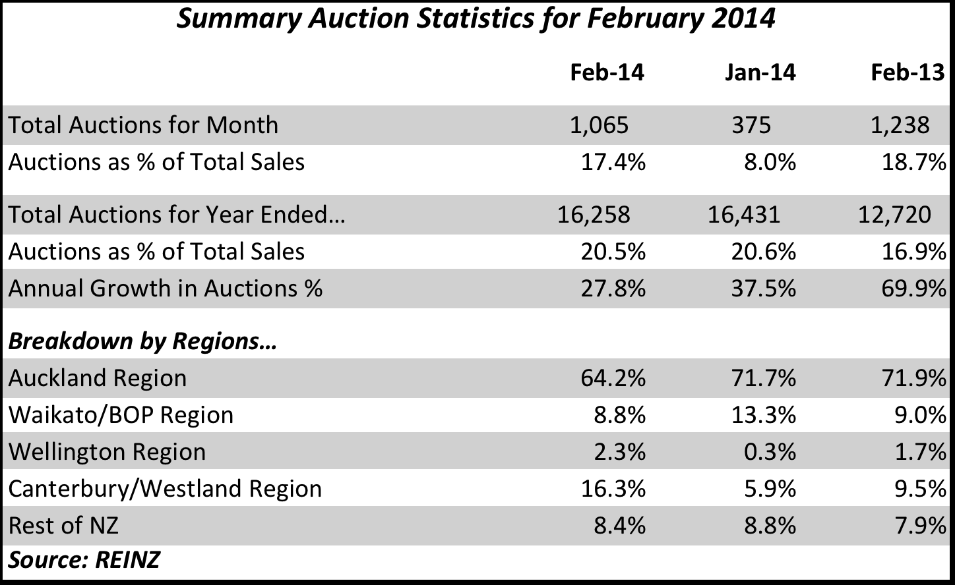

Further Data
Across New Zealand the total value of residential sales, including sections was $3.17 billion in February, compared to $2.33 billion in January, and $3.15 billion in February 2013. For the 12 months ended February the total value of residential sales was $40.22 billion.

The breakdown of the value of properties sold in February 2014 compared to February 2013 is:

 | February 2014 |  | February 2013
$1 million plus | 415 | 6.8% | 295 | 4.4%
$600,000 to $999,999 | 1,169 | 19.1% | 1,071 | 16.1%
$400,000 to $599,999 | 1,641 | 26.8% | 1,742 | 26.3%
Under $400,000 | 2,900 | 47.3% | 3,524 | 53.1%
All Properties Sold | 6,125 | 100.0% | 6,632 | 100.0%

There were 624 fewer (-17.7%) sales under $400,000 in February 2014 compared to February 2013, compared to a drop of 507 sales (-7.6%) for all price brackets between the two periods.

REINZ Stratified Median Housing Price Index
The REINZ Housing Price Index rose 2.1% compared with January to sit at 3,835.9. Auckland rose by 7.1% in February to reach a new record high, Christchurch rose 1.3%, and Wellington rose by 5.4%. For the 12 months to February, the Auckland Index rose 16.9%, the Christchurch Index rose 6.8% and the Wellington Index rose 4.0%. The National Index increased 8.2% compared to February last year.

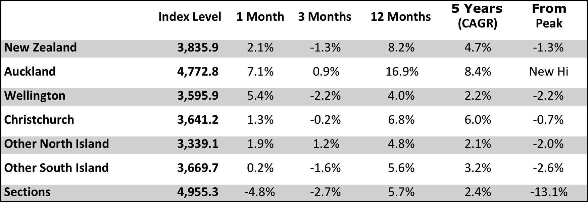

* CAGR is Compound Annual Growth Rate
* The Christchurch data needs to be treated with some caution due to compositional changes in the suburb mix caused by the earthquakes in the city

----- ENDS -----

For more real estate information and market trends data, visit www.reinz.co.nz. For New Zealand's most comprehensive range of listings for residential, lifestyle, rural, commercial, investment and rental properties, visit www.realestate.co.nz - REINZ's official property directory website.
Editor’s Note:
The monthly REINZ residential sales reports remain the most contemporary and up-to-date statistics on house prices and sales in New Zealand. They are based on actual sales reported by real estate agents. These sales are taken as of the date that a transaction becomes unconditional and includes sales as of 5:00pm on the last business day of the month. Other surveys of the residential property market are based on information from Territorial Authorities regarding settlement and the receipt of documents by the relevant Territorial Authority from a solicitor. As such, this information involves a lag of four to six weeks before the sale is recorded by the Territorial Authority.
The REINZ Monthly Housing Price Index is calculated using a technique known as stratification, which provides an averaging of sales prices for common groups of houses. This approach is considered a more robust analysis of actual house price trends and was developed in conjunction with the Reserve Bank.
The REINZ Monthly Housing Price Index is based on a value of 1000 in January 1992, the first month for which electronic information is available. Changes in the index represent movements in housing prices, where the mix of sales between the groups is held constant and are more likely to reflect genuine property price movements.

